**STORE SALES MANAGEMENT**

**ABSTRACT:**

This project aims to improve and monitor sales management system of any company. It is a useful application for keeping track of inventories as all the sales and purchase records like products, stock, management would be managed by computerized system. Some of the main features of the project would include –

* Sales Management
* Revenue Analysis
* Inventory Management
* Shipment Management
* Category Wise Analytics
* Advance Records Searching
* Advance Reports

For backend database we have used MYSQL since SQL queries can be used to retrieve large amounts of records from a database quickly. SQL is used to view the data without storing the data into object and joins two or more tables and shows it as single object to user. Using standard SQL, it is easier to manage database systems without having to write substantial amount of code.

For frontend we have used HTML (Hypertext Markup Language) along with CSS language since HTML is supported by every browser and it is by default in every window so the need to purchase any extra software is eliminated.

It is a dynamic project with database containing 5 different tables with attributes as follows-

* Admin: Admin_Name, Admin_password
* Distributor: Dis_id, Did_name, Dis_pass, Dis_type, Dis_location
* Sales: sales_id, sales_date, sales_cost, s_id
* Stock: cry, scry, quant, s_id
* Store: s_id, s_pass, s_branch_name, s_city, s_region, s_date, s_pcode
* Store Orders: s_id, order_no, Dis_id, order_date, pmtstat, shpmode, shpstat.

**OBJECTIVE:**

Store Sales Management is a project for improving the performance of any company/store. This system can be used to store details of items purchased , sold item , generate bill and inventory management. Some of the main objectives of Store Sales Management system project are as follows:

1. Maintains the details of Sales by Store/Region/State
2. Profits/Sales Analytics
3. Details of Store i.e. No's, Region, Address
4. List of orders which have not been Delivered
5. List of payment paid or pending to the Distributors
6. Profit calculation by date/month/season
7. Maintains the details of product stock.
8. Track Shipment of an Store Order
9. The stock that is to buy if quantity goes less than a particular amount and Profit calculation for a month

**ER DIAGRAM:**

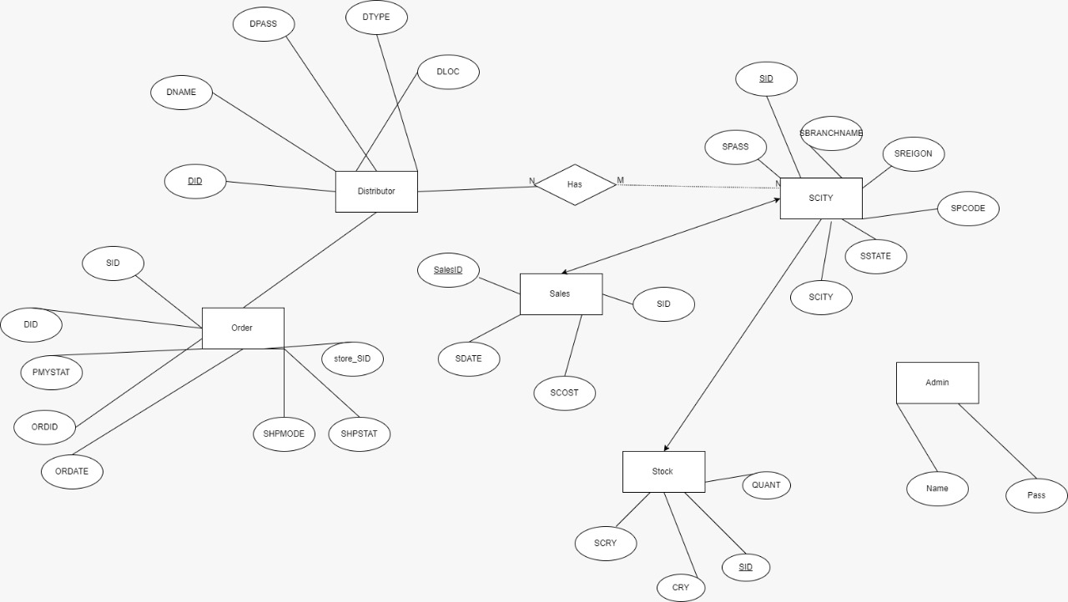

**SCHEMA DIAGRAM:**

